Becoming a Computer Scientist

Kevin Andrade

Binghamton University

Becoming a Computer Scientist

Computer science is a world of competition, and developing your skills is important; Alexander Lawrence Benedict chose computer science. Growing up, Alexander gained the necessary experience and skills to be a well-rounded computer scientist. Based on his leadership, knowledge, and experience, Alexander is a desirable member for the computer science workforce. In his adolescence years, Alexander showed remarkable leadership skills in contributing to the community. Alexander has become knowledgeable in various programing languages, and obtained a lot of experience. Alexander Benedict, born in Rochester, NY, moved to Puerto Rico at the age of four and spent 14 years living there.

In Puerto Rico, Alexander was an active part of the community. When the 2010 Haiti disaster occurred, Alexander sprang into action; from 2010 to 2014, Alexander aided in rebuilding homes and churches in Haiti. Alexander spent many hours creating fundraisers to contribute to the reconstruction of the impacted towns of Haiti. While fundraising, he still contributed to the Puerto Rico community by leading a team to clean up beaches. From his volunteer work, he earned many strong leadership characteristics: passion, dedication, and patience, which he uses during his time at Binghamton University**.**

After 14 years living abroad, Alexander returned to the United States of America proficient in both English and Spanish. Alexander enlisted in the computer engineering degree, at Binghamton University, and became knowledgeable in hardware**.** In classes, such as Intro to Engineering Analysis, he reassembled many household appliances to improve their efficiency**.** Alexander came to the decision to switch to Computer Science; Switching degrees opened the possibility to create hardware and software projects. Since switching majors, Alexander became fluent in Java, C, C++, and Assembly. Fluency in Java and C++ increases Alexander’s job opportunities. Figure 1 illustrates language popularity (Thibaud, 2017, para.17)

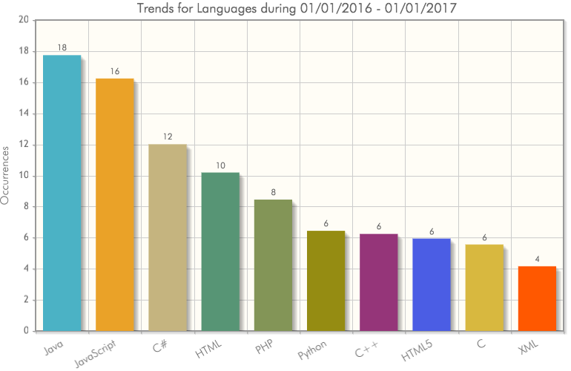

Figure 1. Language popularity.

In Bouwkamps (2016) summary article reviewing the nine most in demand programing languages; Java and C++ are highly in demand. “Java has staying power since it has long-term compatibility, which makes sure older applications continue to work now into the future. It’s not going anywhere anytime soon and is used to power company websites like LinkedIn.com, Netflix.com and Amazon.com.” (Bouwkamps, 2016, para.5). Bouwkamps also mentions that many popular applications are written with C++. “The list includes Adobe and Microsoft applications, MongoDB databases, large portions of Mac OS/X and is the best language to learn for performance-critical applications such as “twitch” game development or audio/video processing.” (Bouwkamps, 2016, para.8) Alexander knows two of the most popular computer languages available. Alexander’s multi language skills make him a desirable asset to many companies. From Alexander’s experiences at Binghamton University, he became knowledgeable.

At Binghamton University, Alexander competed in two hackathons; he successfully completed the competitions using his intellect and leadership skills. Alexander’s first hackathon was in the fall of 2016. Alexander and his partner created a grocery tracking app; the user could add or delete current grocery’s, and generate a separate list of what is needed at home. Alexander oversaw the development of the project, with all his efforts, the app was a success. Alexander created a website to connect employers and applicants in his second hackathon. Applicants would write a short biography, and list their skills; employers would modify their search criteria and connect with potential applicants. In his Sophomore Design course, Alexander programmed a rover to solve itself out of a maze using a light sensor. The rover could go to x, y coordinates using binary numbers; switches surrounding the rover would project the coordinated path. A remarkable project, is his work on a piezo electric crystal. Potentially, the crystal could charge a person’s electronics. The program Solid Edge is used to mold the crystal, modified to fit in a shoe sole; with every step an electric charge is generated, and in the future, it could charge an electronic device. Alexander is a well-rounded computer scientist; his experiences gained his knowledge, and from his knowledge he gained leadership.

Alexander shows that he is capable leading a team to complete his goals; he shows his leadership skills during his community service and hackathons. Alexander is also knowledgeable; He shows his intelligence during the several projects he created, gaining his experience. Based on his leadership, knowledge, and experience, Alexander has the necessary skills to join the computer science workforce. Alexander’s experiences will allow him to fight through the competition, and be an asset to modern businesses.

References

Bouwkamp, K. (2016). The 9 Most In-Demand Programming Languages of 2016. Retrieved

from http://www.codingdojo.com/blog/9-most-in-demand-programming-languages-of-2016/

T. (2017). Top Programming Languages to Learn in 2017. Retrieved from

https://www.codingame.com/blog/wp-content/uploads/2017/01/TrendySkills-Chart.png